Minsun Kim / Emple ID: 1518-8987

**Project # 2 Preview**

First, run the program. (Program will keep coming back to main page until the user choose to close the program.) Run the ParkingLot.java file.

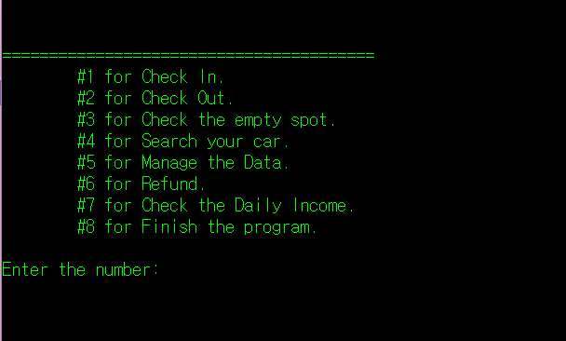

If choose to check-in, you can see the size guide.

After choose the size of the car, you can choose the location. Then, if that location is empty, you can input the data. If that location is occupied, it will show you that place is occupied.

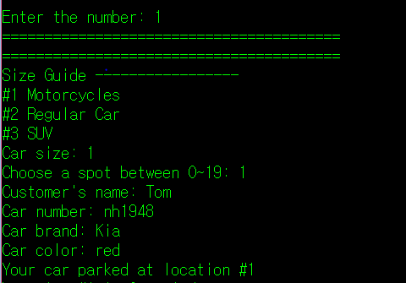 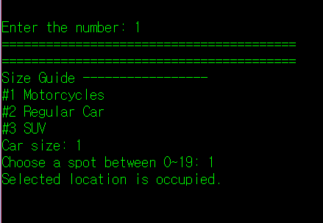

You can add customer as much as you can. (There are 100 spots. 20 for size one, 50 for size two, and 30 for size three).

You can choose the #3 at the main page, so that you can check the empty spot for specific size of car. (I parked 2 car for size 1, 1 car for size 2, and 1 car for size 3)

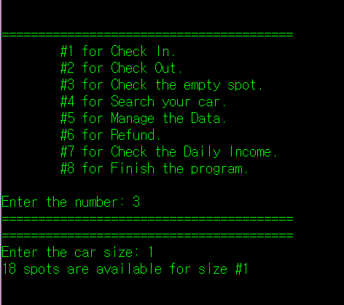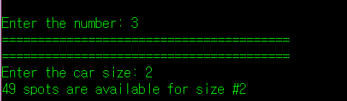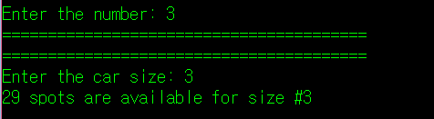

Option # 4 is only for search customer’s car and information of customer. You can search by car number, name of customer, or number of parked location.

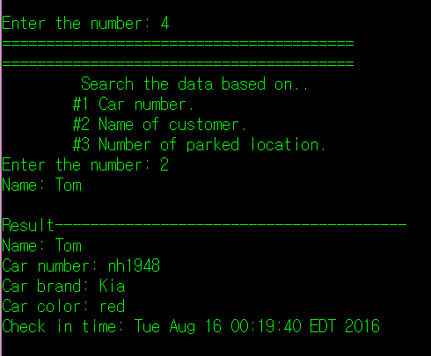

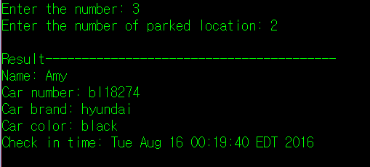

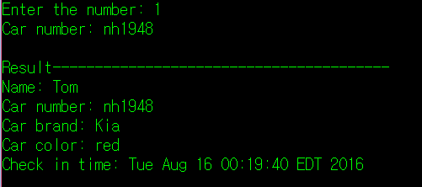

Option # 5 can manage your data. You can organize your data. You can just save the data or you can create a file and save the data permanently. Or you can sort the customer’s name and create sorting file and save the sorted data.

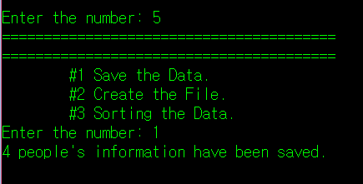

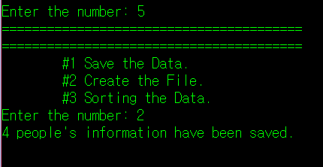

After you save it as file, you can see there is a new file. (Name of the file should be the date of the file created.)



Open the file.

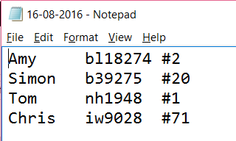

The file has name of the customer, car number, and the parked location.

Now, sorted file.

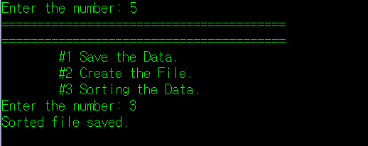

Now, you can see the another file named sorted version.

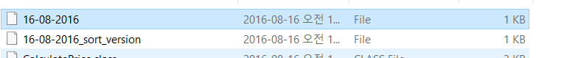

Open it, you can see the name of the customer is now sorted.

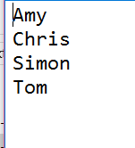

Option # 2 check out on main page, is for check out.

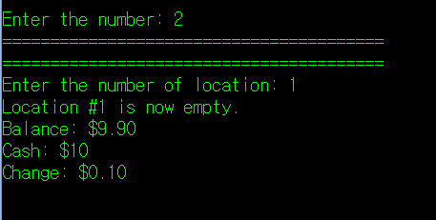

After checkout, program will show you the balance. Then you can input the cash amount.

It will show you the change.

(size 1 - $25/hr size 2 - $30 / hr size3 - $40/hr)

If they park more than 4 hours, it will be $5 per hour since 5th hours.

(example, size 1 or 2 for 4hours - $25, 5 hours - $30 / size 3 for 4 hours - $30, 5 hours - $35)

Then, option # 7. You can check your daily income.

Let’s check out one more car.

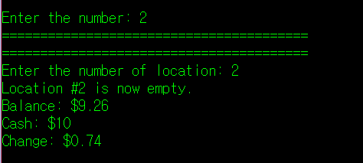

Then, check the income.

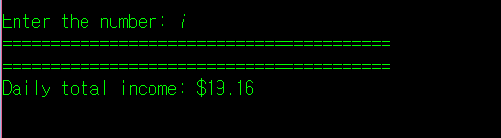

You can also, refund the balance.

Option # 6.

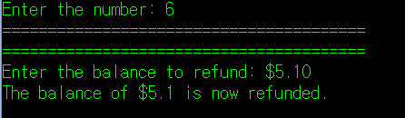

Check the income again.

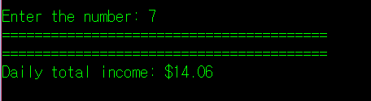

Done.

If you want to close the program, you can enter 8.

